**Experiment-4 (Password Sniffing-Cyber Security Workshop)**

**Login using credentials:**

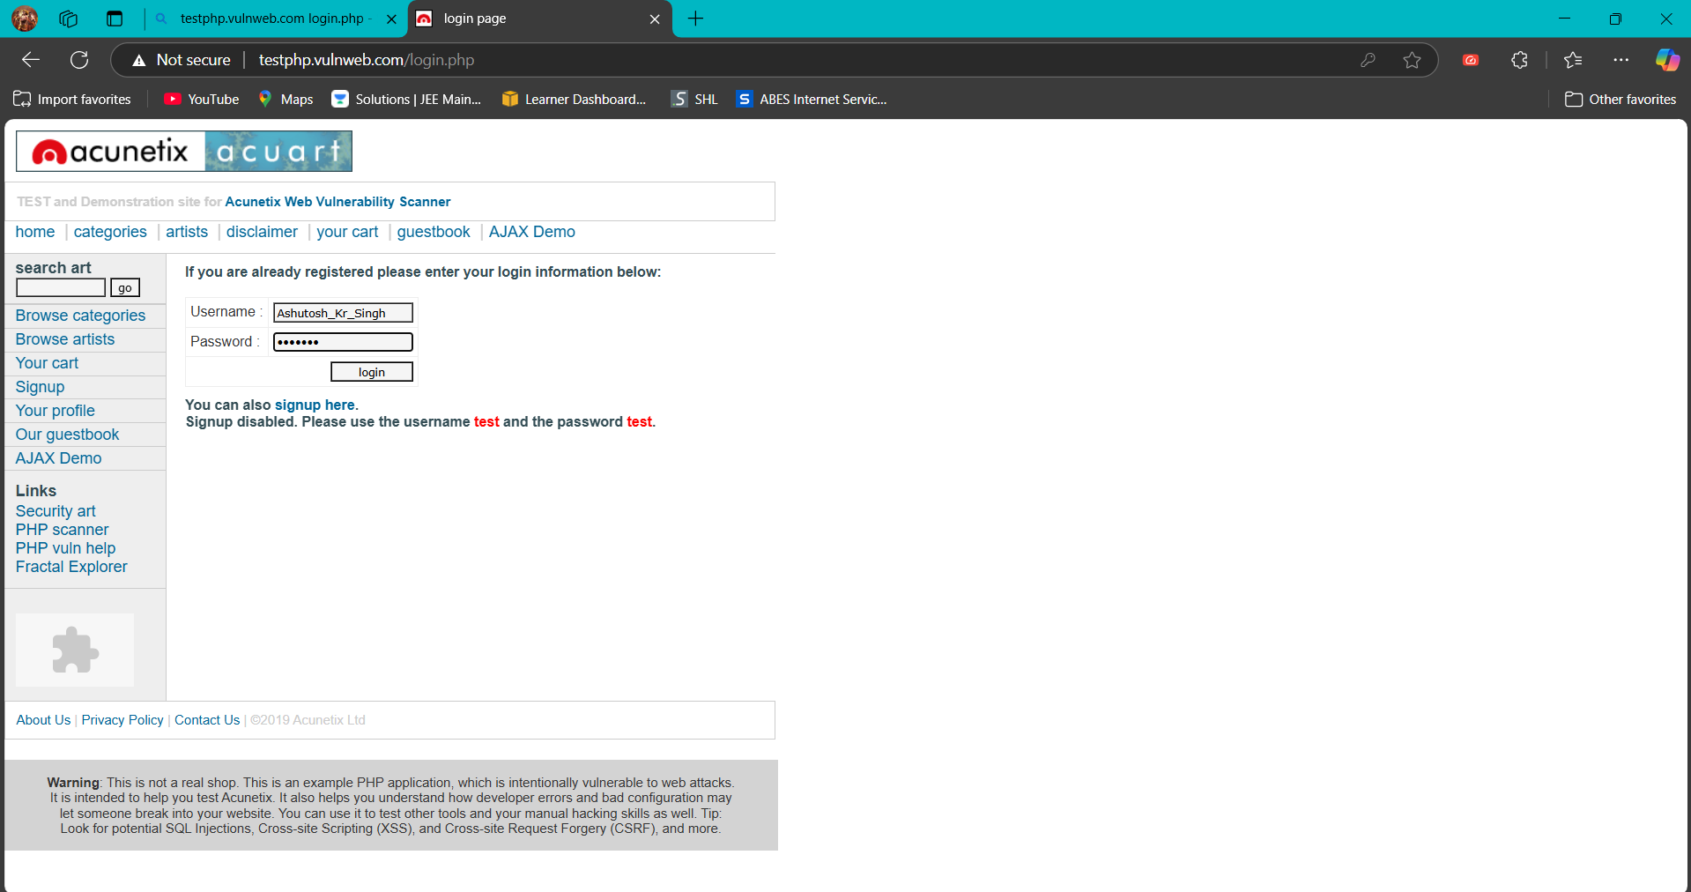

**Apply POST filter & Inspect packet for captured credentials:**

